

**Simplicity Chair - User Guide**

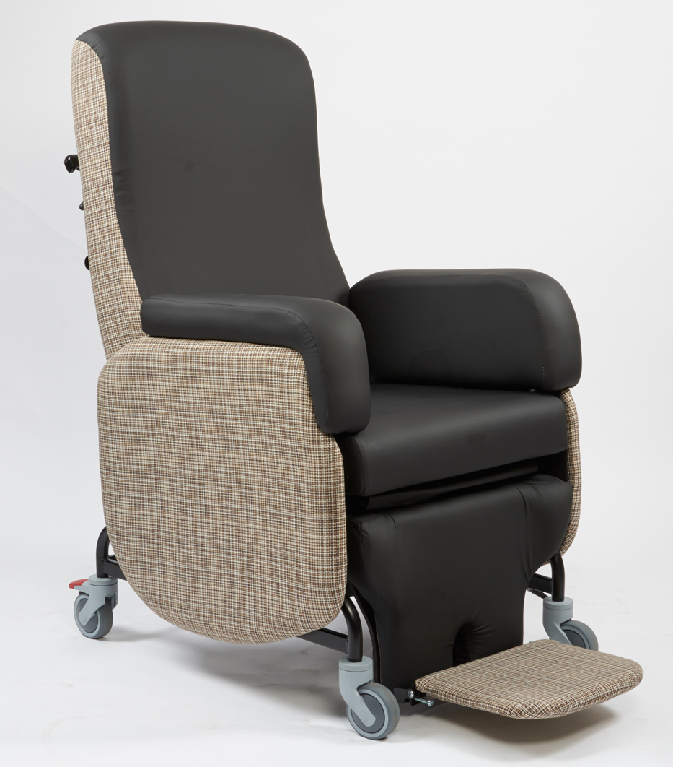**Simplicity Chair - User Guide - Manual**

Primacare Ltd, Unit 26 Heads of the Valleys Industrial Estate, Rhymney, Tredegar NP22 5RL

Telephone (01685) 845900 Fax (01685) 844538

The Simplicity chair is a multi-positional Care Chair which means it can be adjusted in many different ways to help find an individual position for the occupant to give comfort and support.

The following features and adjustment descriptions give a simple guide to using the Simplicity Care Chair.

**Contents:**

1. Tilt in Space
2. Leg Rest Operation
3. Articulating Back
4. Legrest Starting Position
5. Footplate Height Adjustment and Removal
6. Footplate Angle Adjustment
7. Footplate Fold Away
8. Arm Removal
9. Seat Width Adjustment/ Arm Rest Removal
10. Removable Seat Cushion Module
11. Thoracic Width, Angle and Height Adjustment
12. Rear Castor Braking

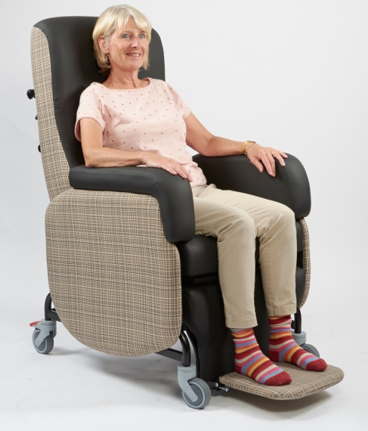

Manual operation

Pull lever and tilt chair. The lever has a safety catch which must be released before squeezing the lever.

1. **Tilt in Space**

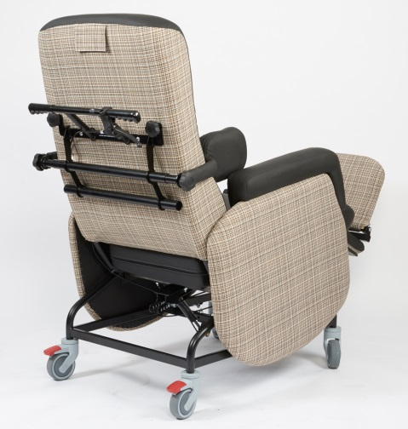 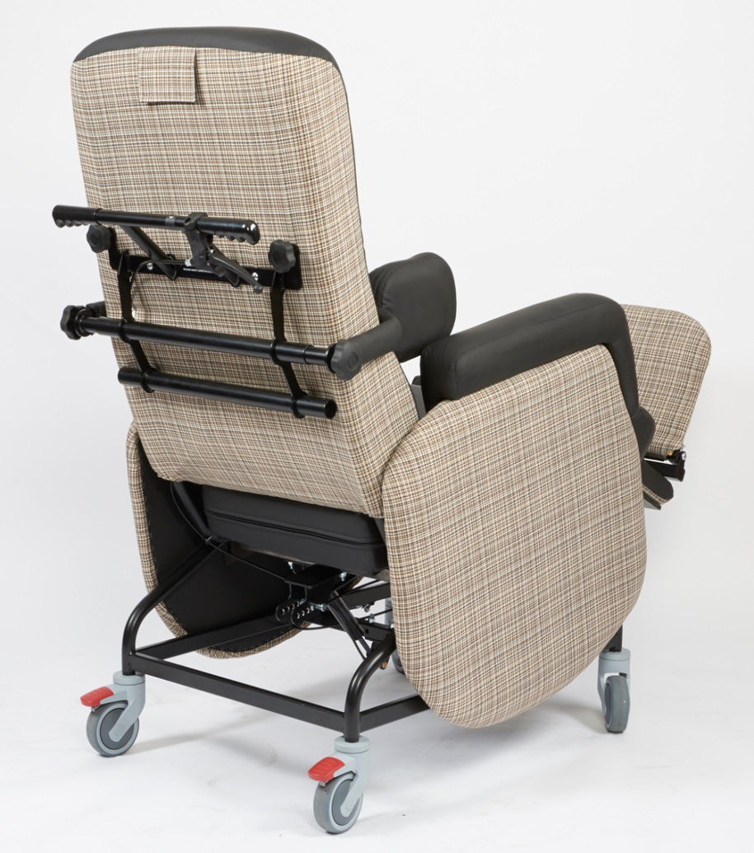

1. **Leg Rest Operation**

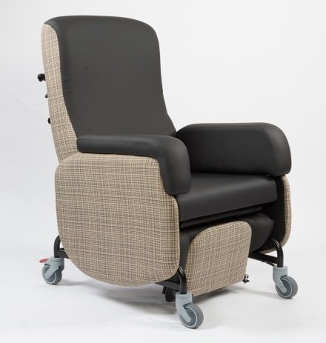

Manual Leg rest operation is a two handed operation. The release trigger must be squeezed as the leg rest is pulled outwards to extend it.

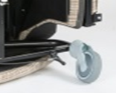

1. **Articulating Back**

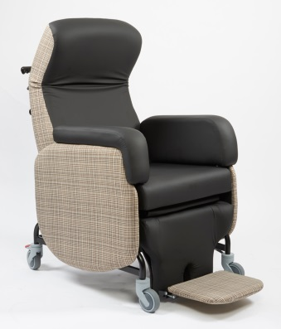

There are two knobs on the back of the chair which allow the carer to change the angle of the upper part of the backrest to give more head support or allow for a kyphotic curvature of the spine.

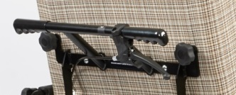

**4. Leg Rest Starting Position**

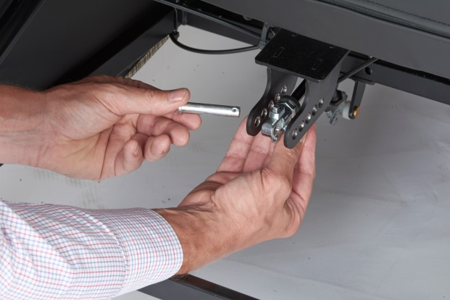

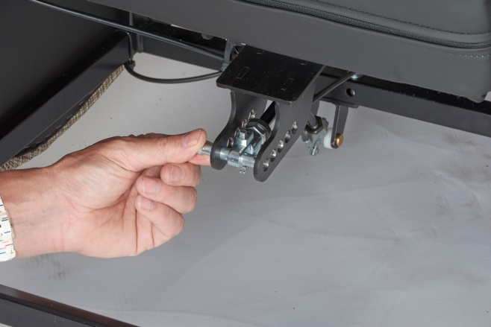

The leg rest gas spring can be positioned at different start points to allow a higher leg rest or a negative angle start.

The pin shown in the pictures is easily repositioned.

1. **Footplate Height Adjustment and Removal**

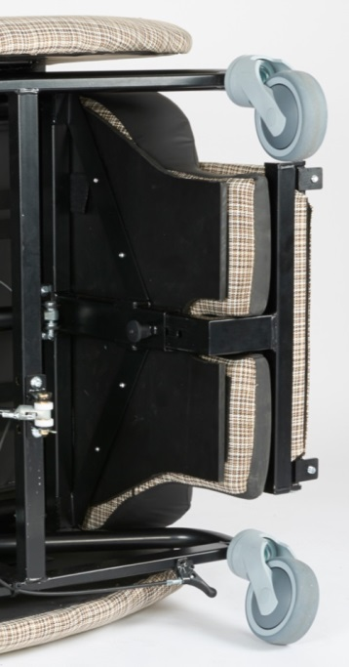

To adjust the height of the footplate the index plunger pin needs to be pulled out and the footplate can be positioned higher or lower in line with the next set of holes.

Footplate removal requires two hands to pull the index plunger out and then slide the footplate out of the leg rest mechanism.

1. **Footplate Angle Adjustment**

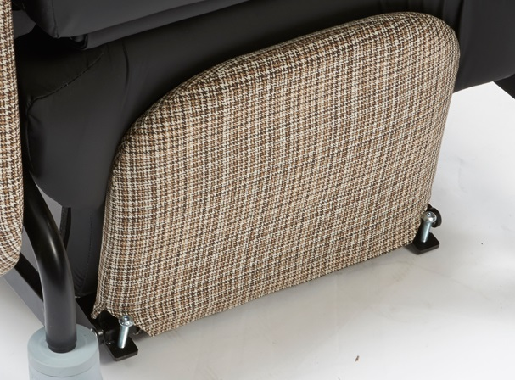

The angle of the footplate can be adjusted using the chromed dome bolts highlighted. It is possible to adjust the angle from -10 degrees to + 20 degrees

1. **Footplate Fold Away**

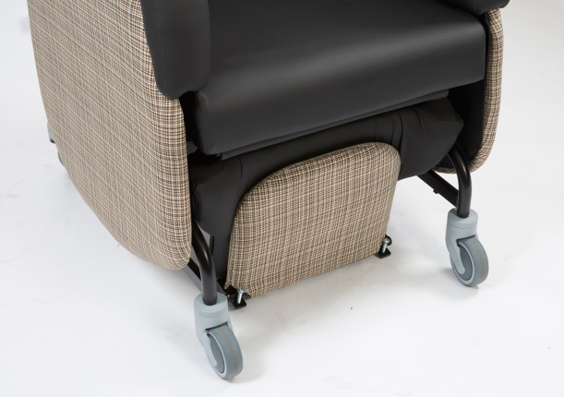

The footplate can be stored in front of the leg rest.

1. **Arm Removal**

The arms are removable vertically

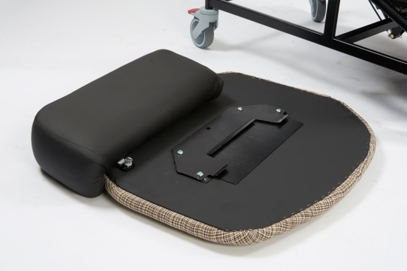

1. **Seat Width Adjustment/ Arm Rest Removal**

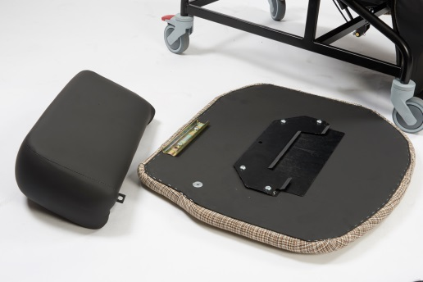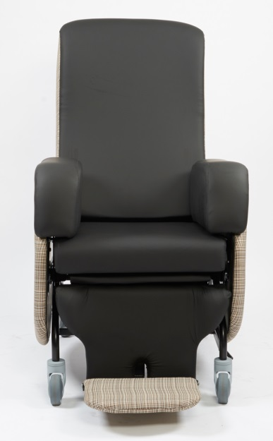

Arm rests come in different size pairs to achieve different seat widths, 400mm, 450mm and 500mm. To adjust the seat width by removing the arm rest and replacing with a different size, remove the retaining butterfly screws and slide the arm rest off.

1. **Removable Seat Cushion Module**

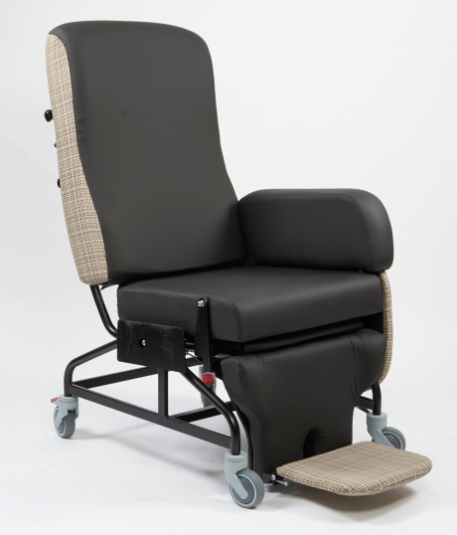

The seat module can be removed to allow the addition of other seat foam/gel/air cushion systems.

The cushion casing is secured to the seat with Velcro and can be repositioned giving some depth adjustment.

**11. Thoracic Supports Width, Angle and Height Adjustment**

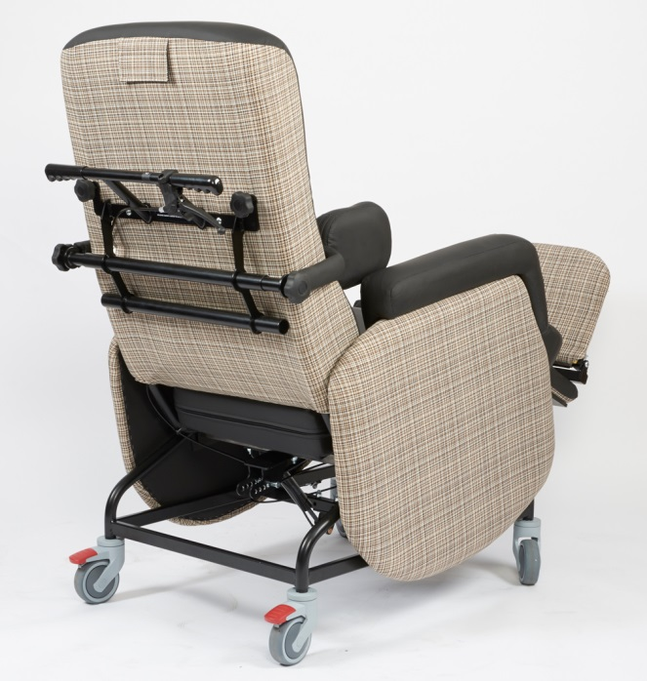

The thoracic supports are locked in place with the large external knob.

There are two support tubes.

By loosening the large knob the thoracic support can be positioned wider or at a different angle to suit the client’s needs.

**12. Rear Castor Braking**

The rear locking castor is locked in the attached photograph. This is easily done with the carer’s foot operating the brake lever.

It is advisable to lock the castors whenever the client is in the chair in a stationary position.

