

Broadway Porter Chair - User Guide
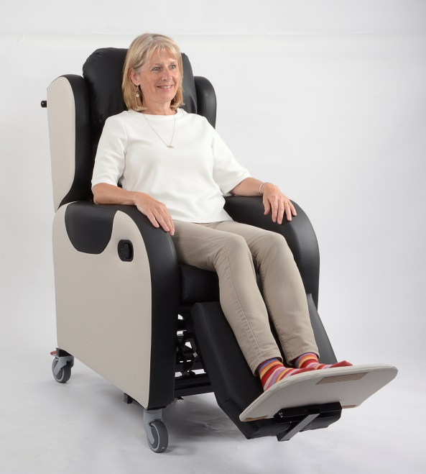
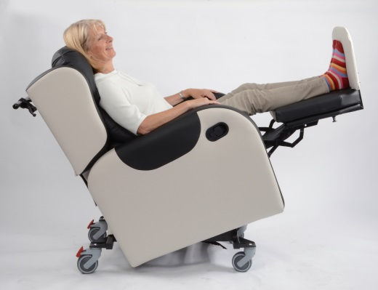
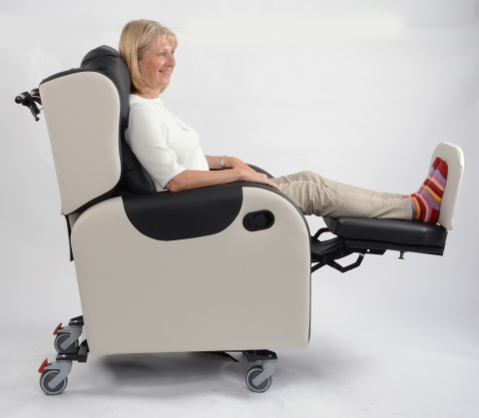
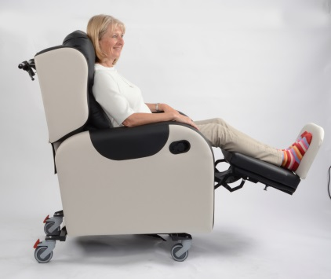
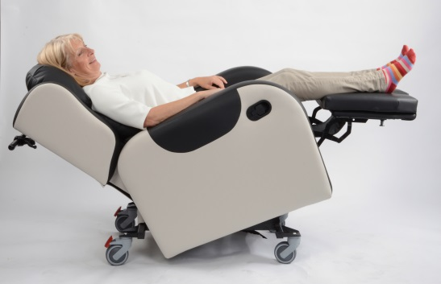
Primacare Ltd, Unit 26 Heads of the Valleys Industrial Estate, Rhymney, Tredegar NP22 5RL
Telephone (01685) 845900 Fax (01685) 844538
Primacare Ltd, Unit 26 Heads of the Valleys Industrial Estate, Rhymney, Tredegar NP22 5RL
Telephone (01685) 845900 Fax (01685) 844538
Broadway Porter Chair - User Guide

The Broadway Porter chair is a multi-positional Level 3 Care Chair which means it can be adjusted in many different ways to help find an individual position for the occupant to give comfort and support.
The following features and adjustment descriptions give a simple guide to using the Broadway Porter Chair.
Contents:
- Tilt in Space. Electric or Manual
- Leg Rest Operation. Electric or Manual
- Back Angle Recline (B.A.R.) Electric or Manual
- Footplate Height Adjustment and Removal
- Footplate Angle Adjustment
- Removable Seat Cushion Module
- Rear Castor Braking
- Back Cushion Adjustment
- Battery Charging

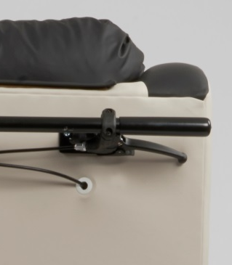
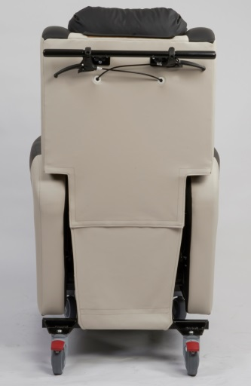
- Tilt in Space

Electric operation
Top two buttons tilt chair back and forwards
Manual operation
Pull lever and tilt chair

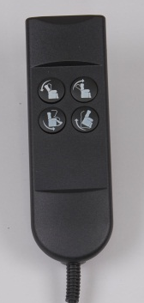

- Leg Rest Operation

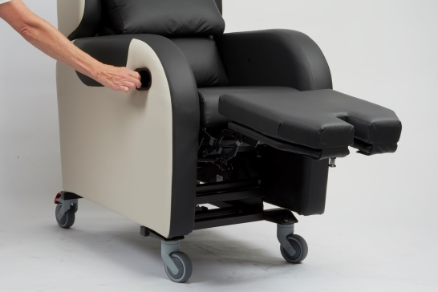
Manual Leg rest operation is a two handed operation. The release trigger must be squeezed as the leg rest is pulled outwards to extend it.
Electric operation of the leg rest is with the two lower buttons on the handset.

- Back Angle Recline

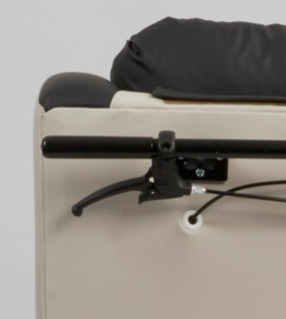
Manual Back Angle Recline is the lever on the left of the handle and this needs to be squeezed to enable manually moving the backrest to a more reclined or upright position.

- Footplate Height Adjustment and Removal

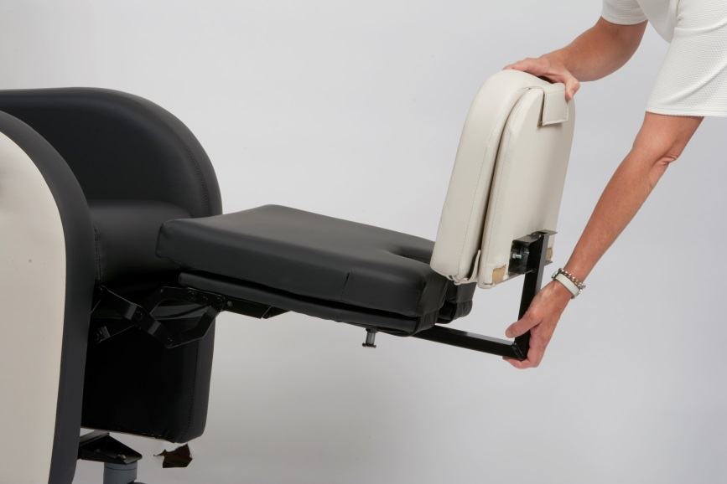
To remove the footplate the index plunger pin is pulled out and the footplate can be completely removed from the chair.

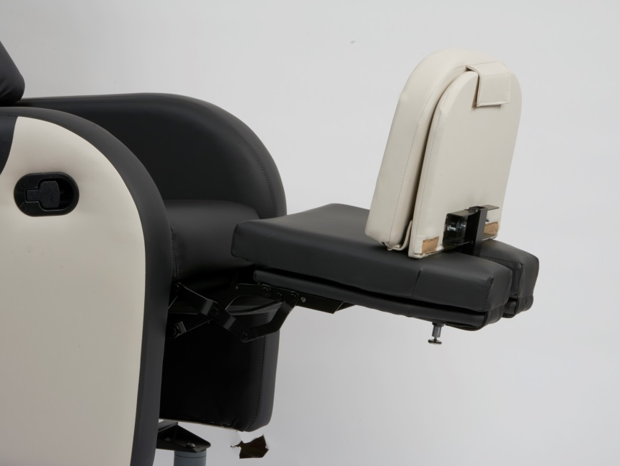
Footplate removal requires two hands to pull each of the index plungers out and then slide the footplate off the leg rest mechanism.

To adjust the height of the footplate the index plunger pin is pulled out and the footplate can be positioned higher or lower in line with the next set of holes.

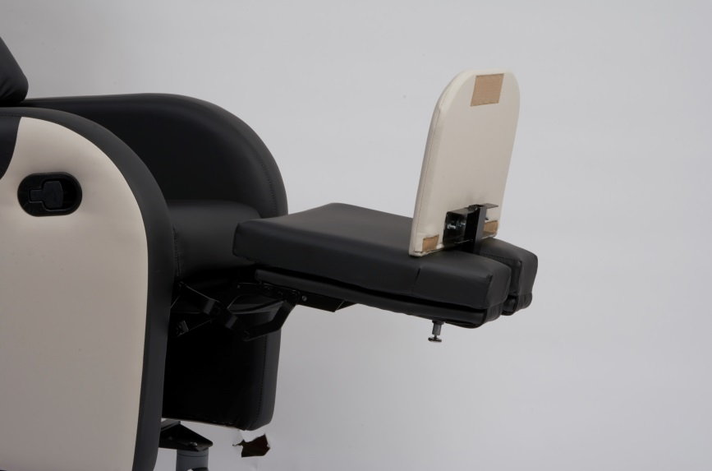

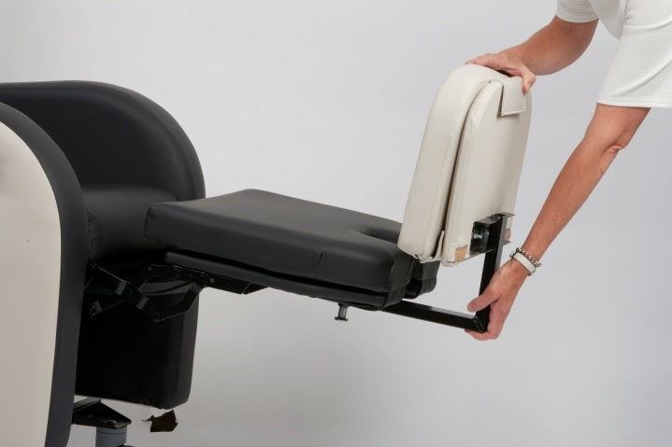
5.Footplate Angle Adjustment

The angle of the footplate can be adjusted using the plunger pin.. It is possible to adjust the angle from -10 degrees to + 20 degrees

- Removable Seat Cushion Module

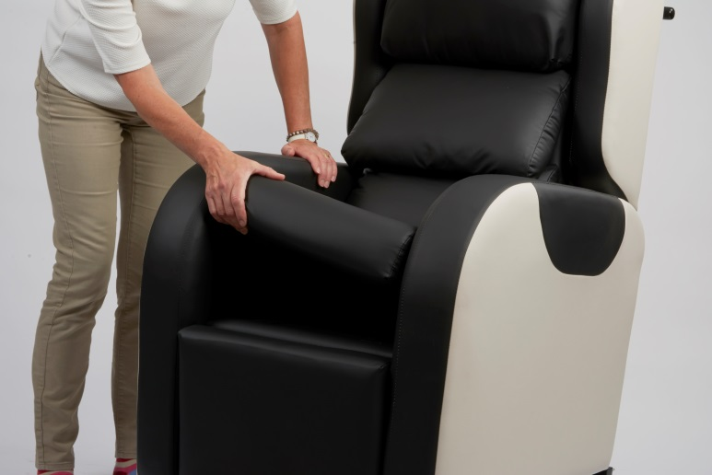
The seat module can be removed to allow the addition of other seat foam/gel/air cushion systems.
The cushion casing is secured to the seat with Velcro.

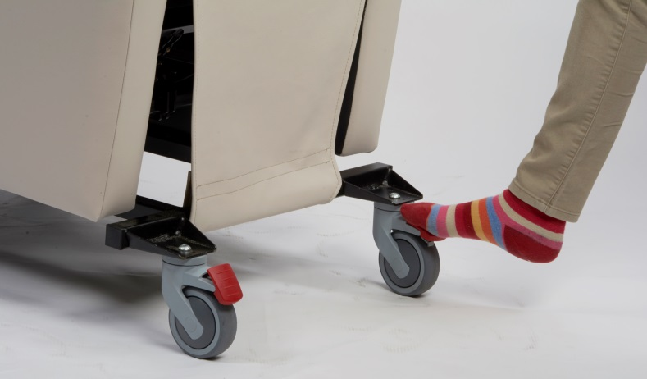
The rear locking castor is locked in the attached photograph. This is easily done with the carer’s foot operating the brake lever.
It is advisable to lock the castors whenever the client is in the chair in a stationary position.
7. Rear Castor Braking

8. Back Cushion Adjustment

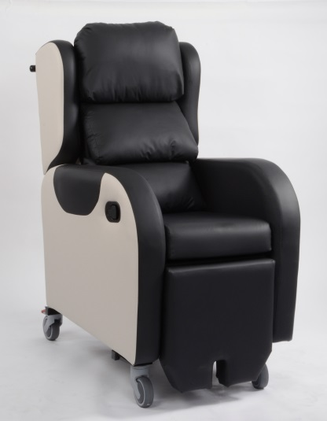
The back cushions on the Broadway Porter Chair are attached with Velcro and can easily be repositioned to suit the shape of the service user.

9. Battery Charging

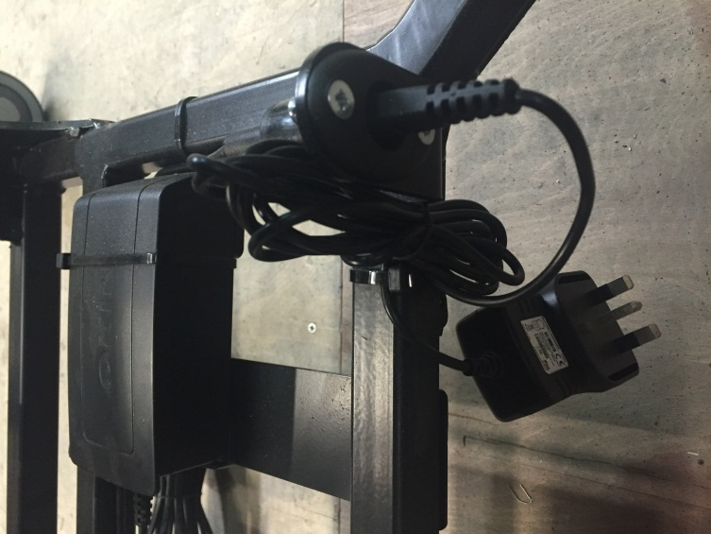
Rechargeable Battery

The charging lead can be easily disconnected from the supply to enable free movement of the chair. We recommend charging the battery at least weekly. A full charge should allow for at least 50 cycles of operation of the chair.

The charging transformer should be plugged in to a 240V socket.

